A
PROJECT REPORT ON
Online Wedding Planner System
SUBMITTED IN
PARTIAL FULFILLMENT OF

DIPLOMA IN ADVANCED COMPUTING (PG-DAC)
BY
190840820032 – Ganesh H. Kathar.
190840820112 - Dipika B. Wagh.
UNDER THE GUIDENCE OF

Girish Barhate.
AT
SUNBEAM INSTITUTE OF INFORMATION TECHNOLOGY, PUNE
SUNBEAM INSTITUTE OF INFORMATION TECHNOLOGY,
PUNE.
CERTIFICATE
This is to certify that the project
Online Wedding Planner System
Has been submitted by
190840820032-Ganesh H. Kathar.
190840820112 – Dipika B. Wagh.

In partial fulfillment of the requirement for the Course of PG Diploma in Advanced Computing (PG-DAC AUG2019) as prescribed by The CDAC ACTS, KARAD.
Place: Karad | Date: 30-JAN-2020
<Project Guide Name> | <Alumni Mentor Name>
Project Guide | Alumni Mentor

ACKNOWLEDGEMENT
Online Institute Management System provides a common platform for student,teacher and admin to manage activities like adding course , joining course , viewing various details about there activities like attendance, marks etc . This will help teachers to keep track of various important details like making announcement, sharing various info about the course he is going to teach. Admin will have all mode access as he will be able to all the details about students, teachers and courses and will be able to track activities off institute.

ABSTRACT

The wedding planner is a java web application which helps to organize successful wedding events for users. This application provides an easy way to plan their special events. The user can add all the details of the event and can get the service. The user can select the type of event ,date of event and estimated budget. All the details given by users will be verified by admin. Admin will add all the details of the planner based on the requirement of the user and send the user’s event details to the planner. The planner will verify and send his response with a confirmation mail. The user needs to complete the payment process to confirm the order
INDEX
 | INTRODUCTION | 1
 | 1.1 Introduction | 2
 | Product Overview and Summary
 | 2.1 Purpose
 | 2.2 Scope
 | 2.3 User Classes and Characteristics
 | 2.4 Design and Implementation Constraints
 | REQUIREMENTS
 | 3.1 Functional Requirements
 | 3.1.1 Use case for Administrator.
 | 3.1.2 Use case for Customer.
 | 3.2 Non - Functional Requirements
 | 3.2.1 Usability Requirement
 | 3.2.2 Performance Requirement
 | 3.2.3 Reliability Requirement
 | 3.2.4 Portability Requirement
 | 3.2.5 Security Techniques
 | PROJECT DESIGN
 | 4.1 Data Model
 | 4.1.1 Database Design
 | 4.2 Process Model
 | 4.2.1 Functional Decomposition Diagram
 | 4.2.2 Data Flow Diagram (DFD)
 | TEST REPORT
 | PROJECT RELATED STATISTICS
 | CONCLUSION
LIST OF TABLES
Section | Table Title | Page
4. | Table1:T_Role_Table
 | Table2:T_User_Table
 | Table3:T_OTP_Table
 | Table4:T_User_Details_Table
 | Table5:T_L_Type_Table
 | Table6:T_Application_Table
 | Table7:T_Exam_Table
 | Table8:T_Exam_Details_Table
 | Table9:T_Response_Table
 | Table10:T_Exam_Result_Table
 | Table11:T_License_Table

LIST OF FIGURES
Section | Figure Title | Page

1.INTRODUCTION

2. Product Overview and Summary

Online wedding planner system provides a common platform for customer and wedding suppliers.The system eases the tedious task of planning and organizing a wedding.The customer search and book wedding venue based on location,availability or their budget with all these feature integrated at one place the customer can place the wedding quickly and efficienty.
Functionalities of design pages:-
project contain modules:
User
Admin
Planner

*User :
1.login:
In user login page it contains user’s username and password.if user is already registered then user click login button,otherwise click on the registration button.

2.Registration:
In user registration we are taking input from user like emailid as username,password should be 8 character including special character,number,character.date of birth in the form of like dd/mm/yyyy format,gender,address,mobile number etc.and after filling these information click on register button.
After sucessfully login of user it will click on Add event details button.after clicking on the add event button goes to the next page.

3.Add Event Details:
it contains username ,location of wedding/venue ,estimated budget and date of function and planner list after that click on submit details.

4.Make Payment:
After that for making payment click on payment in that there is option for add amount and option for using net banking or credit card or debit card after that click on make payment.

5.Find Panner:
After clicking on find planner user have to search planner name and then user will get information about planner and after that if user want add planner then click on add button.

6.Member Details:
In that user can add the number of guest invited to wedding after that the information added.

PLANNER:

1.Log in:
In planner login page it contains planner’s username and password.if planner is already registered then planner click login button,otherwise click on the registration button.

2.Registration:
In planner registration we are taking input from planner like emailid as username,password should be 8 character including special character,number,character,gender,mobile number etc.and after filling these information click on register button.

3.User Details:
In this,planner can see information about users.

3.Payment Details:
Payment details and number of guests will shown.

ADMIN PAGE:

1.Log in:
In admin login page it contains admins’s username and password.after taking input from admin click on login button.after login admin can see buttons like user details,add planner details,user request,planner response and logout.
2.User Detail:
After clicking on user details then admin can see all information about user.

3.Add Planner:
After clicking on add planner details like user name,emailid,estimated budget,address,mobile number.

4.User Request:
Then admin can see user request and planner respnose.
5.Planner Request:
Then admin can see planner request.

Use Case

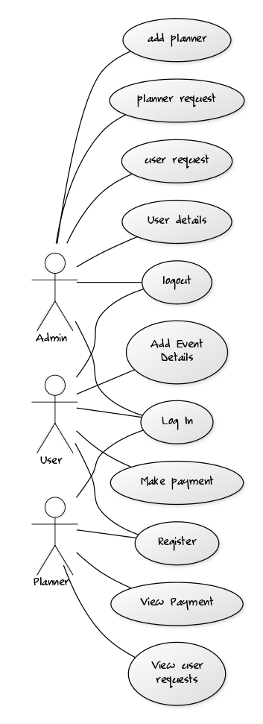

4.PROJECT DESIGN
Table1:Booking_Table

Table2:customer

Table3:event

Table4:PLANNER_TABLE
Table5:ROLE_TABLE

Table6:Venue_table

Table7:payment_detail

Appendix B
HOME PAGE,ADMIN LOGIN AND REGISTERATION,USER DETAILS PAGE
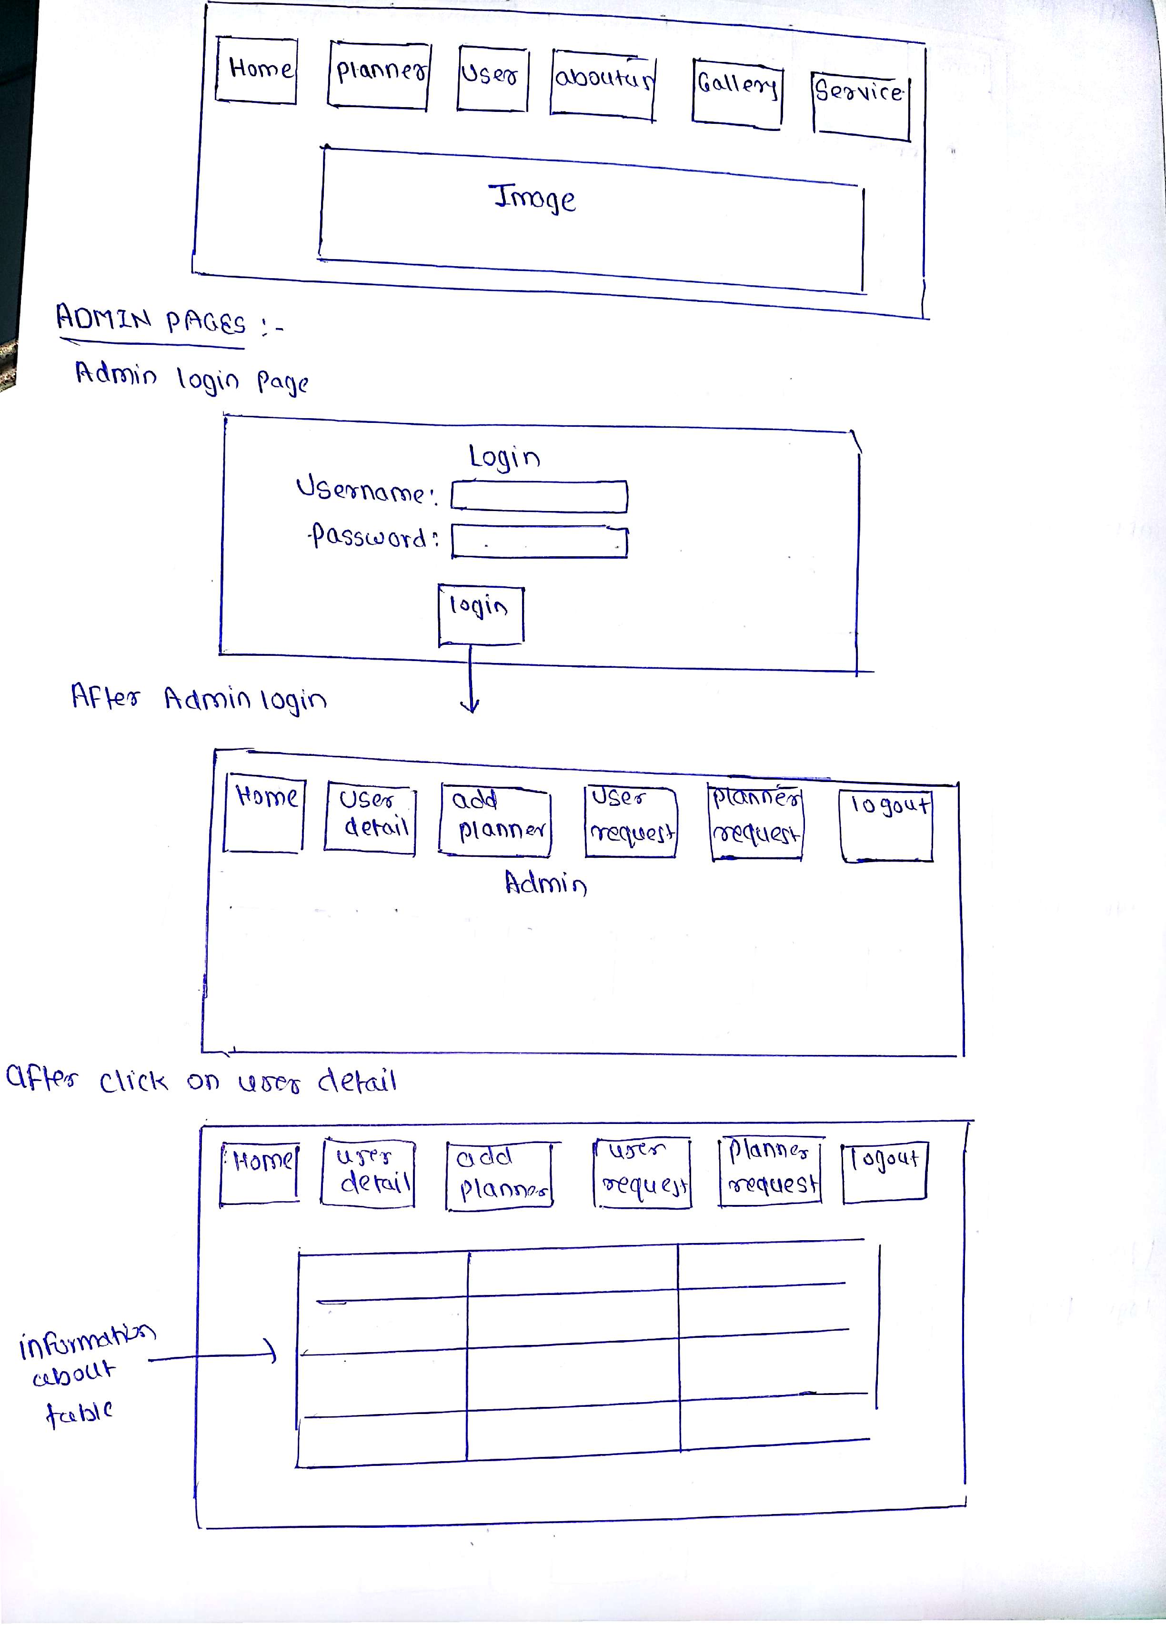

ADD PLANNER,USER REQUEST,PLANNER REQUEST AND USER LOGIN PAGE
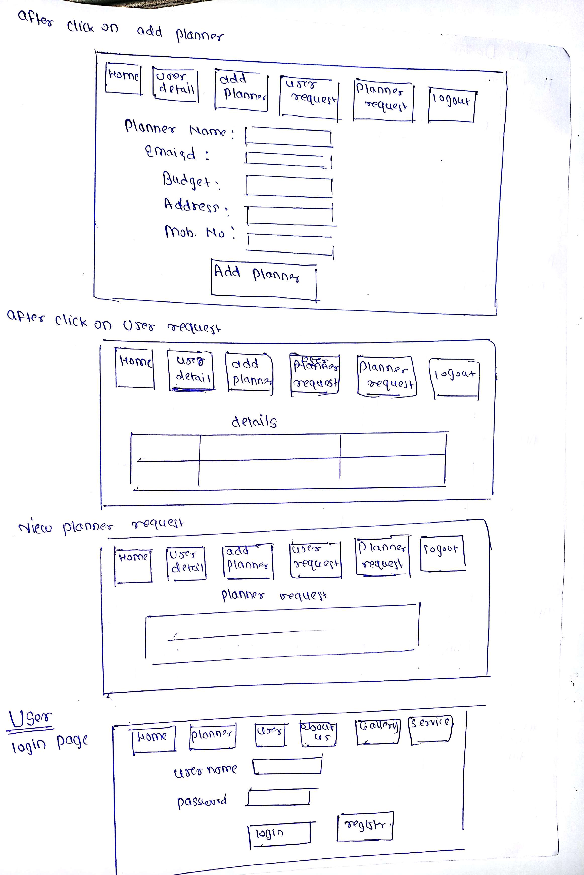

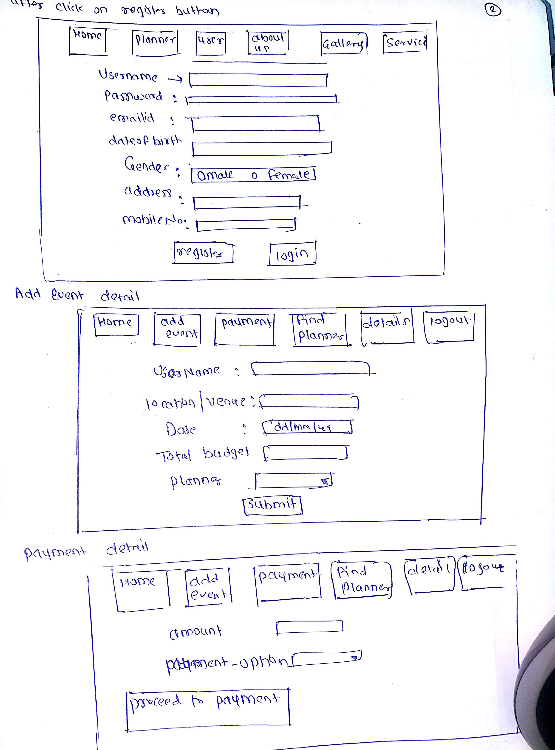
USER REGISTERATION,ADD EVENT DETAILS,PAYMENT DETAIL
FIND PLANNER,DETAILS OF MEMBER,PLANNER LOGIN AND REGISTRATION
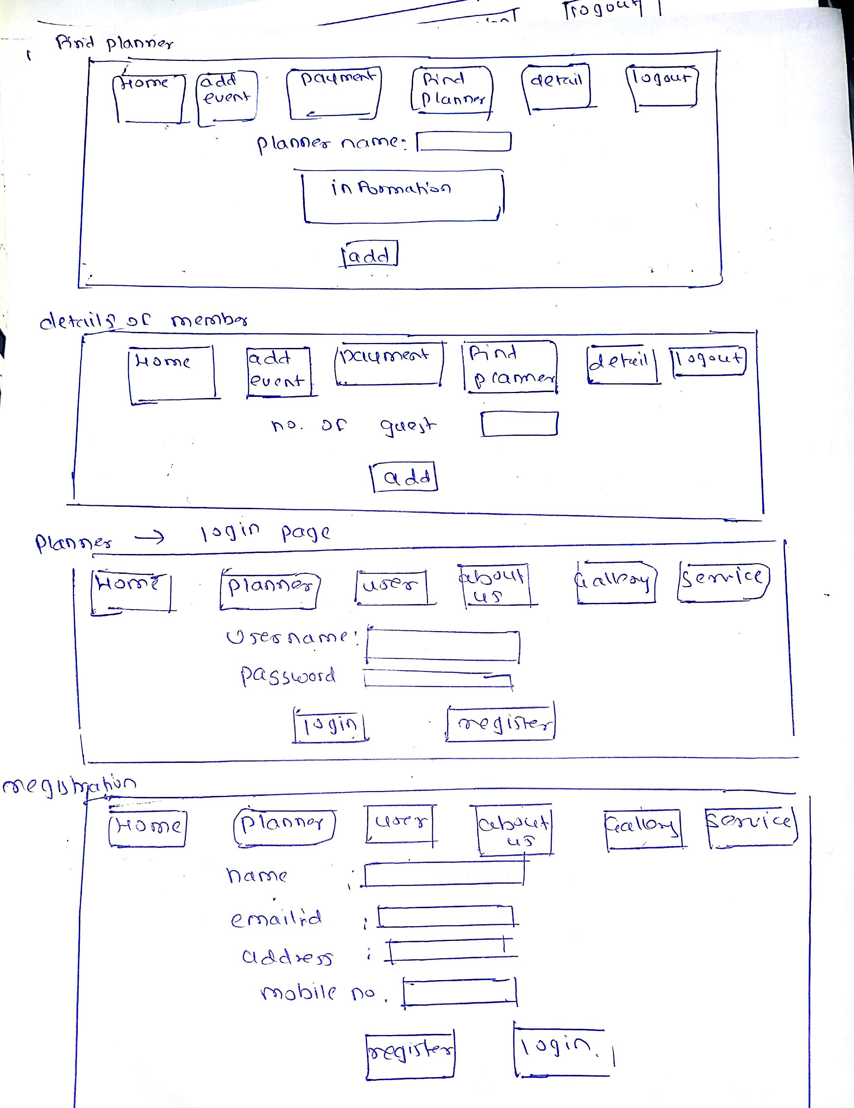
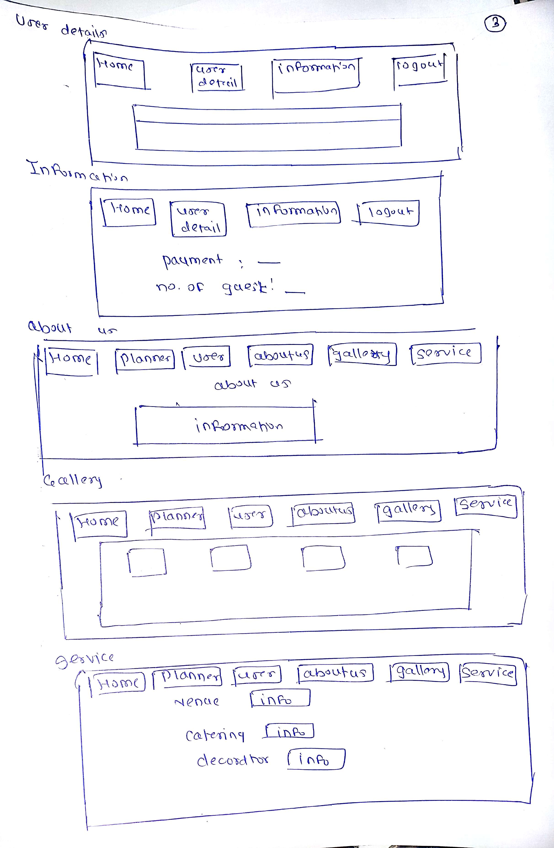
USER DETAILS,INFORMATION,ABOUT US,GALLERY,SERVICE

